Georeferencing for Research Use Follow-Up Survey Rev
February 14th 2017, 1:02 pm EST
Please indicate whether your use of the resources listed below has increased, decreased, or stayed the same since the GRU workshop.
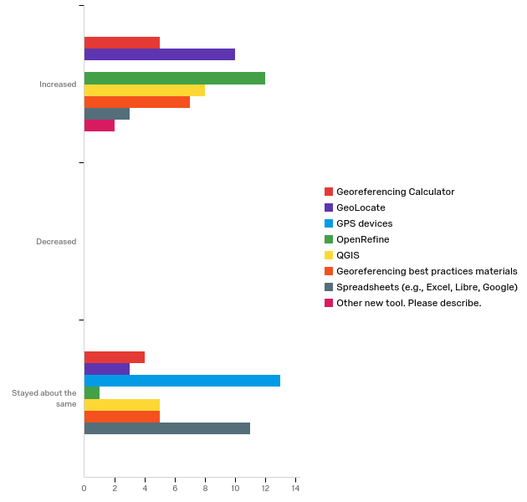

# | Question | Increased |  | Decreased |  | Stayed about the same |  | Total
4 | Georeferencing Calculator | 55.56% | 5 | 0.00% | 0 | 44.44% | 4 | 9
5 | GeoLocate | 76.92% | 10 | 0.00% | 0 | 23.08% | 3 | 13
6 | GPS devices | 0.00% | 0 | 0.00% | 0 | 100.00% | 13 | 13
7 | OpenRefine | 92.31% | 12 | 0.00% | 0 | 7.69% | 1 | 13
8 | QGIS | 61.54% | 8 | 0.00% | 0 | 38.46% | 5 | 13
10 | Georeferencing best practices materials | 58.33% | 7 | 0.00% | 0 | 41.67% | 5 | 12
11 | Spreadsheets (e.g., Excel, Libre, Google) | 21.43% | 3 | 0.00% | 0 | 78.57% | 11 | 14
9 | Other new tool. Please describe. | 100.00% | 2 | 0.00% | 0 | 0.00% | 0 | 2

Other new tool. Please describe.
Other new tool. Please describe.
GeoODKCollect
R code for GeoLocate

Looking toward the future, do you anticipate that your use of each resource will increase, decrease, or stay the same?
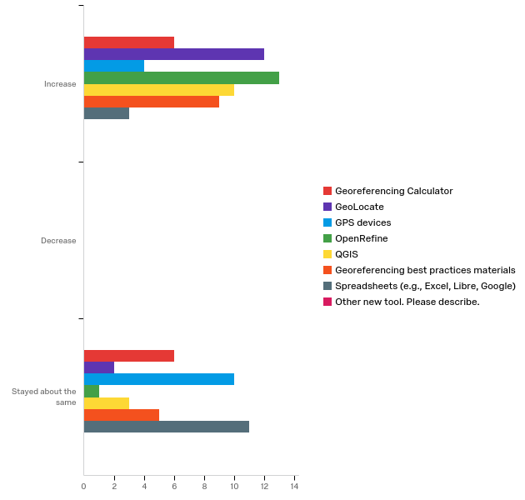

# | Question | Increase |  | Decrease |  | Stayed about the same |  | Total
4 | Georeferencing Calculator | 50.00% | 6 | 0.00% | 0 | 50.00% | 6 | 12
5 | GeoLocate | 85.71% | 12 | 0.00% | 0 | 14.29% | 2 | 14
6 | GPS devices | 28.57% | 4 | 0.00% | 0 | 71.43% | 10 | 14
7 | OpenRefine | 92.86% | 13 | 0.00% | 0 | 7.14% | 1 | 14
8 | QGIS | 76.92% | 10 | 0.00% | 0 | 23.08% | 3 | 13
10 | Georeferencing best practices materials | 64.29% | 9 | 0.00% | 0 | 35.71% | 5 | 14
11 | Spreadsheets (e.g., Excel, Libre, Google) | 21.43% | 3 | 0.00% | 0 | 78.57% | 11 | 14
9 | Other new tool. Please describe. | 0.00% | 0 | 0.00% | 0 | 0.00% | 0 | 0

If you would like to explain your ratings, please do so in the space below.

I hope to incorporate these resources, particularly GeoLocate, once I reach that stage of my research.
We tend to use Google Maps for quick visualisation of data exported from our MyPestGuide Reporter app, we use Surfer for journal publications. We are locked in to in-house GIS software for high level work so probably can't work with QGIS.
I have already been using some of the tools presented at the workshop, but I intend to use some more frequently, especially to refine and prepare our data for our TCN to serve to iDigBio. Learning some tools to help with data quality up front and at data entry for research use in the future was a big help. Thank you!

If you teach, how do you plan to incorporate what you learned into your courses?

I hope to hold a short hands on georeferencing workshop locally.
I have already presented a formal workshop and seminar for students at the uprrp zoology museum, to teach them about idigbio, darwin core, and database workflow etc... They are all working now on databasing and/or digitizing our collections, and teaching new students themselves!
I do not teach, but i have trained several of my interns in the use of Open Refine.
N/A

Please rate your expertise with GEOLocate prior to the workshop.
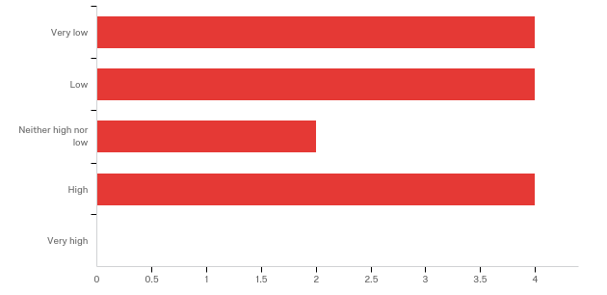

# | Answer | % | Count
1 | Very low | 28.57% | 4
2 | Low | 28.57% | 4
3 | Neither high nor low | 14.29% | 2
4 | High | 28.57% | 4
5 | Very high | 0.00% | 0
 | Total | 100% | 14

How does your confidence using GEOLocate now compare to that prior to the workshop?
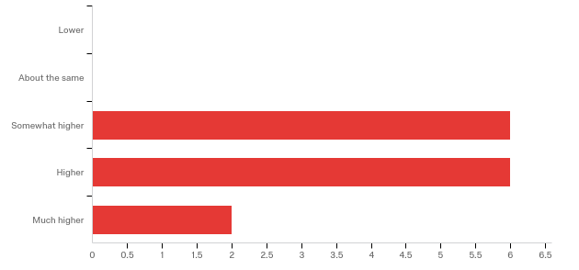

# | Answer | % | Count
1 | Lower | 0.00% | 0
2 | About the same | 0.00% | 0
3 | Somewhat higher | 42.86% | 6
4 | Higher | 42.86% | 6
5 | Much higher | 14.29% | 2
 | Total | 100% | 14

How do you use GEOLocate? Please check all that apply.
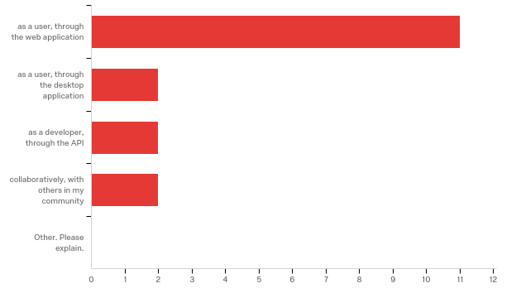

# | Answer | % | Count
4 | as a user, through the web application | 91.67% | 11
5 | as a user, through the desktop application | 16.67% | 2
6 | as a developer, through the API | 16.67% | 2
7 | collaboratively, with others in my community | 16.67% | 2
8 | Other. Please explain. | 0.00% | 0
 | Total | 100% | 12

Please rate your expertise with QGIS prior to the workshop.
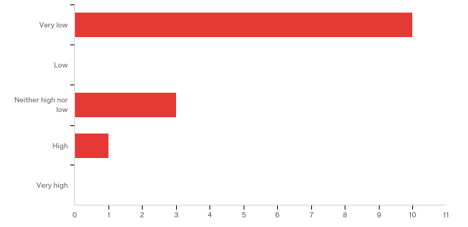

# | Answer | % | Count
1 | Very low | 71.43% | 10
2 | Low | 0.00% | 0
3 | Neither high nor low | 21.43% | 3
4 | High | 7.14% | 1
5 | Very high | 0.00% | 0
 | Total | 100% | 14

How does your confidence using QGIS now compare to that prior to the workshop?
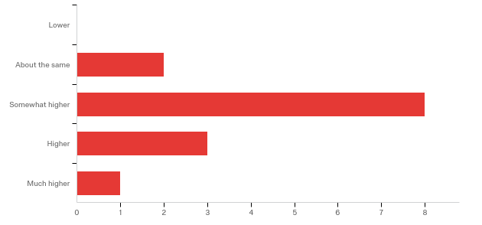

# | Answer | % | Count
1 | Lower | 0.00% | 0
2 | About the same | 14.29% | 2
3 | Somewhat higher | 57.14% | 8
4 | Higher | 21.43% | 3
5 | Much higher | 7.14% | 1
 | Total | 100% | 14

How do you use QGIS? Please check all that apply.
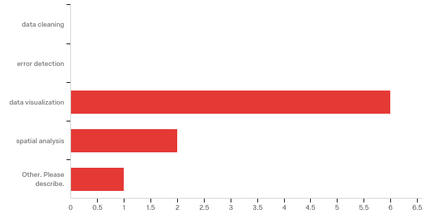

# | Answer | % | Count
4 | data cleaning | 0.00% | 0
5 | error detection | 0.00% | 0
6 | data visualization | 75.00% | 6
7 | spatial analysis | 25.00% | 2
8 | Other. Please describe. | 12.50% | 1
 | Total | 100% | 8

Other. Please describe.
Other. Please describe.
spatial analysis

Please rate your expertise with OpenRefine prior to the workshop.
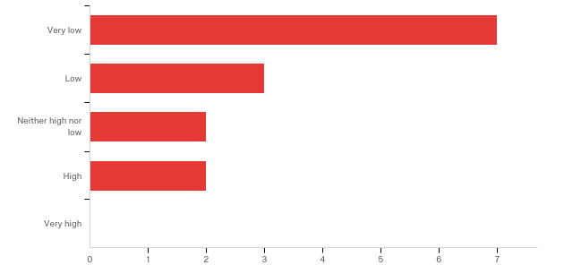

# | Answer | % | Count
1 | Very low | 50.00% | 7
2 | Low | 21.43% | 3
3 | Neither high nor low | 14.29% | 2
4 | High | 14.29% | 2
5 | Very high | 0.00% | 0
 | Total | 100% | 14

How does your confidence using OpenRefine now compare to that prior to the workshop?
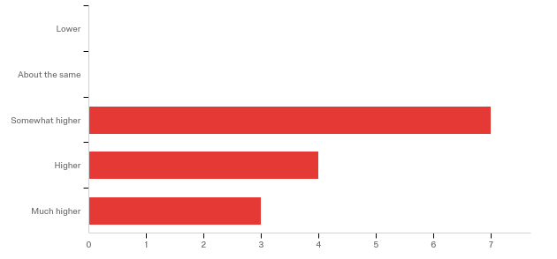

# | Answer | % | Count
1 | Lower | 0.00% | 0
2 | About the same | 0.00% | 0
3 | Somewhat higher | 50.00% | 7
4 | Higher | 28.57% | 4
5 | Much higher | 21.43% | 3
 | Total | 100% | 14

How do you use OpenRefine? Please check all that apply.
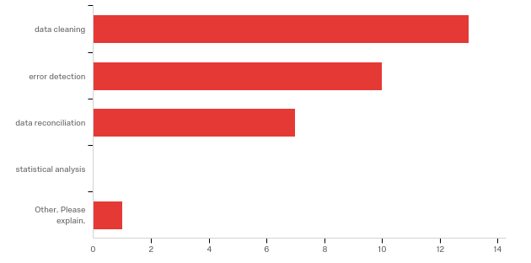

# | Answer | % | Count
4 | data cleaning | 92.86% | 13
5 | error detection | 71.43% | 10
6 | data reconciliation | 50.00% | 7
7 | statistical analysis | 0.00% | 0
3 | Other. Please explain. | 7.14% | 1
 | Total | 100% | 14

Other. Please explain.
Other. Please explain.
I do not use it

Further training in the advanced features of the following programs would be beneficial to my research. Please check all that apply.
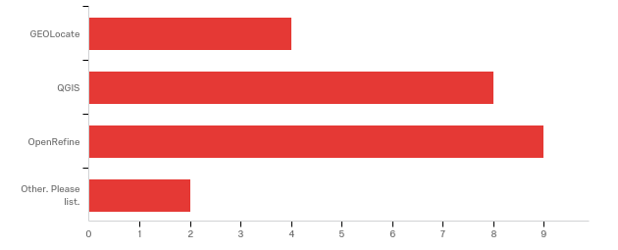

# | Answer | % | Count
4 | GEOLocate | 33.33% | 4
5 | QGIS | 66.67% | 8
6 | OpenRefine | 75.00% | 9
7 | Other. Please list. | 16.67% | 2
 | Total | 100% | 12

Other. Please list.
Other. Please list.
GIS in R / Python
Inselect

We are interested in knowing whether you have made any colleagues aware of the materials used in the workshop. Please estimate the number of colleagues you have pointed toward the workshop materials.
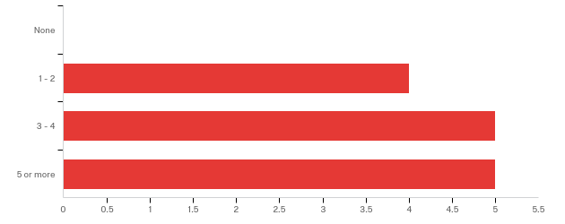

# | Answer | % | Count
1 | None | 0.00% | 0
2 | 1 - 2 | 28.57% | 4
3 | 3 - 4 | 35.71% | 5
4 | 5 or more | 35.71% | 5
 | Total | 100% | 14

Please indicate the ways you have shared your knowledge of the various georeferencing tools since the workshop.
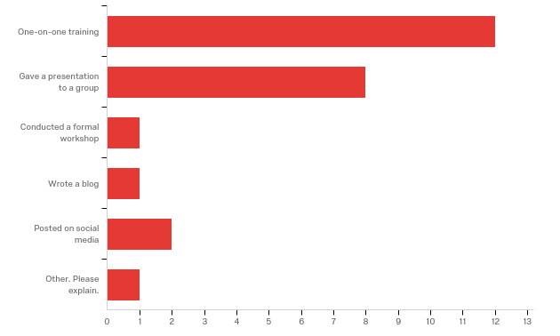

# | Answer | % | Count
2 | One-on-one training | 92.31% | 12
4 | Gave a presentation to a group | 61.54% | 8
5 | Conducted a formal workshop | 7.69% | 1
6 | Wrote a blog | 7.69% | 1
7 | Posted on social media | 15.38% | 2
8 | Other. Please explain. | 7.69% | 1
 | Total | 100% | 13

Other. Please explain.
Other. Please explain.
Discussed highlights of data cleaning, quality, and consistency with others in our TCN
With whom have you shared the knowledge you gained at the workshop? Please check all that apply.
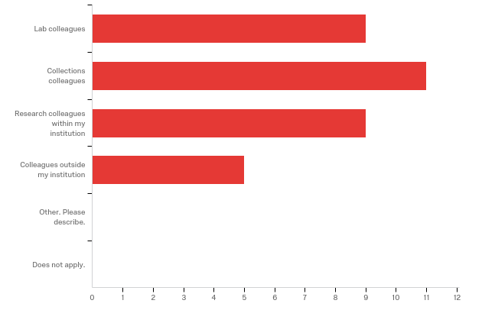

# | Answer | % | Count
4 | Lab colleagues | 64.29% | 9
5 | Collections colleagues | 78.57% | 11
6 | Research colleagues within my institution | 64.29% | 9
7 | Colleagues outside my institution | 35.71% | 5
8 | Other. Please describe. | 0.00% | 0
3 | Does not apply. | 0.00% | 0
 | Total | 100% | 14

Briefly describe the content and the audience involved in the above (e.g., I trained an undergrad volunteer on OpenRefine.)

I showed our project manager and two collections managers how to use GeoLocate and helped them with some OpenRefine questions.
I showed my colleagues how to use these tools in their workflow for simple tasks of data prep and visualizing.
Trained several undergraduate interns in Open Refine, introduced the program to my collections colleagues and several colleagues outside the collections.
I trained collection managers within the NC Museum of Natural Sciences on using OpenRefine to clean data. I additionally trained undergrads on OpenRefine to clean up their research data.
I showed Graduate students the georeferencing materials and Geolocate
I demonstrated OpenRefine to lab and GIS colleagues as well as discussed with other colleagues at a national (NBIGEG) workshop.
I've trained undergrad and graduate volunteers and employees on OpenRefine and GeoLocate.
I trained department/collections staff in OpenRefine.
I trained undergrad and graduate students working in the labs, and discussed the thematics of the workshop with our database staff and the researchers.
I have worked with and helped train several students in using GeoLocate to georeference our locality data

Q22 - If you have any additional comment or feedback, please share below.
If you have any questions or comments, please share below.

