Supplementary material to:
Underwood & Grace (2017) The use of biodiversity data in rural development programming. RIO Journal. (EU BON project publications).

The use of biodiversity data in rural development programming
Evelyn Underwood & Miriam Grace

Supplementary material to the following sections:

Relevant biodiversity indicators and data sources
Common Farmland Bird Index
Conservation status of agricultural habitats - grassland
High Nature Value (HNV) farming
Uses of biodiversity data to better target agricultural support measures – case studies
UK – England - agri-environment targeting framework
Monitoring the impact of agri-environment schemes on biodiversity
Monitoring biodiversity impacts of agri-environment and organic farming in Estonia
Methodology of the Welsh Glastir Monitoring and Evaluation Programme (GMEP)
Proposal for wild pollinator monitoring scheme in the UK
The IFAB arable biodiversity and landscape features survey

Relevant biodiversity indicators and data sources

Common Farmland Bird Index

Example of a national farmland breeding bird survey scheme – Ireland

The Irish Common Farmland Bird Index is produced using data from the Countryside Bird Survey, coordinated by BirdWatch Ireland, which began recording in 1998 (Crowe, Coombes and O’Halloran, 2014). For the period between 1998 and 2013, 20 common farmland bird species in Ireland showed increasing trends, 16 species declined, and 17 were stable (Crowe, Coombes and O’Halloran, 2014). The survey design uses a random stratified sampling approach. Counting is based on observations made while walking two 1km parallel transects within a 1km square, randomly assigned to the volunteer. The square is allocated through a process in which the Republic of Ireland was divided into eight regions. 10km squares, based on the Irish National Grid, were randomly selected within each region and assigned in sequence. Within each 10km square, the 1km square at the south-west corner is surveyed, and squares with less than 50% land are excluded, therefore approximately 700 squares are surveyed. Two counting visits are made in a year, the first in the early part of the breeding season (early April to mid-May) and the second at least four weeks later (mid-May to late June). Only adults are counted. The timing is designed to capture the presence of residents and early migrants in the first visit and late migrants in the second. Recorders are asked to begin their counts between 6:00 and 7:00 am to target maximum bird activity, and discouraged from recording in unfavourable weather conditions. Each 1km transect is divided into five 200m sections for observations. Ideally, the same square is surveyed every year by the same observer, and transect routes are 500m apart and 250m from the edge of the square, but this is often not possible. For each species recorded, the maximum of the two counts is used as the annual measure of relative abundance. Annual population indices are calculated with TRIM. The stratified sampling design results in an unequal representation of the Irish regions, so annual counts are weighted by the inverse of the proportion of the region surveyed.

Common Farmland Bird Index calculation with TRIM

Species count data are collected by volunteer surveyors as part of national monitoring schemes is used by national coordinators to produce yearly indices and trends. These are delivered to the Pan-European Common Bird Monitoring Scheme (PECBMS), coordinated by the European Bird Census Council, the Royal Society for the Protection of Birds and Birdlife International, to produce supranational species and trends, which are used to calculate the multispecies EU Farmland Bird Index. The EU Common Farmland Bird index combines breeding population data of 39 bird species which are classed as farmland habitat-specific and relatively common. These data are computed from the values of the multi-species indicator based on the geometric mean of individual species indices. The published European indices are calculated relative to 1980 as the base year and a slightly modified version of TRIM is used. The PECBMS coordination unit checks all national species indices using quantitative criteria to assess whether the values appear reasonable. Suspicious data are not used to calculate supranational trends, and these trends are in turn checked for consistency.

The TRIM (Trends and Indices for Monitoring data) programme is used to control for the effect of missing values, which are common in count data. The TRIM software allows the output of national indices that include the estimated effects of missing counts. Missing values are estimated from data from other sites using Poisson regression, in a process called imputation. The basic TRIM model is a generalised linear model (GLM) with a log-link function and a Poisson error term: α γ
,

where α_{i} is the effect for site i and γ_{j} the effect for year j on the natural log of expected counts µ_{ij}. The open-source program Species Trends Analysis Tool for birds (BirdSTATs) provides the TRIM functionality in batch processing mode. TRIM and BirdSTATs allow the generation of imputed yearly indices and totals for each species, standard errors and covariances. The TRIM software also outputs the multiplicative and additive population trends. When new data become available, the entire previous dataset is recalculated to provide new estimates.

The EU index combines breeding population data of 39 bird species which are classed as farmland habitat-specific and relatively common. These data are computed from the values of the multi-species indicator based on the geometric mean of individual species indices. The published European indices are calculated relative to 1980 as the base year and a slightly modified version of TRIM is used. The PECBMS coordination unit checks all national species indices using quantitative criteria to assess whether the values appear reasonable. Suspicious data are not used to calculate supranational trends, and these trends are in turn checked for consistency.

Conservation status of agricultural habitats - grassland

Many Member States have carried out field surveys of grassland habitats to inform their reporting under the Habitats Directive. However, very few Member States have complete and up-to-date inventories covering semi-natural farmland habitats, and most of the datasets on habitats within Natura 2000 areas need further improvement and/or updating. Some examples of national level spatial grassland datasets are given in the Table.

Spatial semi-natural grassland datasets in some Member States
Sources: (datagvat, 2015); (UBA, 2015); (UBA, 2013); (Jordbruksverket, 2013); (JNCC, 2007)

MS | Dataset | Quality and limitations | Uses
AT | Trockenrasenkatalog | Digital vector map of 682 dry grassland parcels dated 1986: much of the information is out of date.
AT | Biotope (Habitat) extent (vegetation surveys) – grassland, scrub, woodland, arable, moorland | Presence/absence of selected semi-natural habitat types (biotopes) in grid cells (5-6 km grid). Habitats defined according to Austrian habitat type classification.
AT | EUNIS habitat map | 10m resolution, dated 2013. Uses habitat survey maps from the federal states where these are available; in other federal states other data sources were used. | Identifies the sensitive habitats specified under the Nitrates Directive as sensitive to critical loads of nitrogen.
EE | Estonian Nature Information System EELIS | Database on Semi-natural Habitats
SE | National Survey of Meadows and Pastures - TUVA databasen | Inventory of 270,000 ha of species-rich grassland (7,000 ha meadows, 229,000 ha pastures, 34,000 ha needs restoration). Original survey 2002 to 2004 with some updates 2007-2013. New survey is underway since 2016. | Used to evaluate and check on environmental compensation and other measures and for advice, community planning and research.
UK | UK Biodiversity Action Plan priority habitat map | 25m resolution, dated 2011. The map was developed using a combination of satellite images and national scale digital mapping data. Habitat types classified according to the UK Broad Habitats Classification. | Used in combination with other data sources in a regional targeting framework for allocation of competitive agri-environment funding.

High Nature Value (HNV) farming

HNV farmland map at electoral district level in Republic of Ireland
The likely occurrence and distribution of HNV farmland in the Republic of Ireland at the electoral division level was mapped using national datasets (Matin et al. 2016). The indicators used were semi-natural habitat cover (deduced from CORINE land cover 2012), stocking density (LPIS data), hedgerow density (from national hedgerow survey), river and stream density (from Ordinance Survey map) and soil diversity (from soil types map), with highest weightings placed on the first two indicators (40% and 30%, respectively). The indicators were scaled between 0 and 1 and mapped onto a 2 km x 2 km grid (masked with the 1 km x 1 km map of agricultural land and the electoral divisions), which was then used to create a score of likelihood of HNV occurrence at electoral district (LAU-2) level. The colour assigned to each grid square indicates the likelihood of finding HNV farms in this area. However, in reality each 2 km x 2km square will contain a range of farms, from intensively to extensively managed. The map is therefore not useful for targeting farm scale action or funding, though it does give an indication of which regions in the country may require most support, and Ireland’s RDP 2014–2020 identifies that the HNV concept is still not fully established in Ireland.

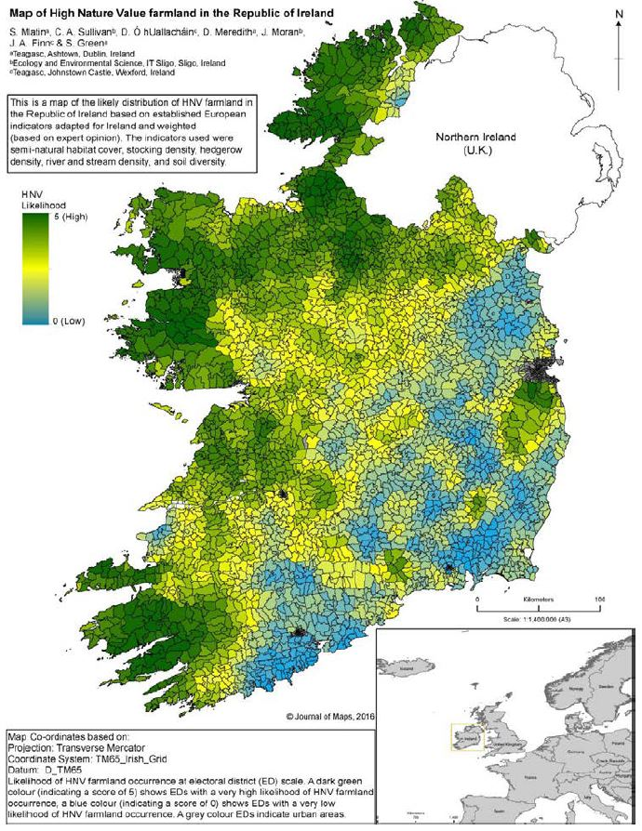
Figure reproduced from (Matin et al. 2016).

Example of an HNV monitoring methodology - Germany

In Germany, the HNV baseline indicator was developed in response to the lack of suitable pre-existing land type data. An initial assessment coordinated by the Federal Agency for Nature Conservation (Bundesamt für Naturschutz) found that the available datasets lacked complete habitat type coverage, with important habitats such as arable land and traditional orchards not included. In addition, monitoring was too infrequent for the data to be used as an indicator. A new approach was therefore developed to enable the identification and monitoring of HNV farmland (PAN, IFAB and ILN, 2011).

The distribution and extent of HNV farmland is assessed by field surveys of 900 sample plots of 1 km2 distributed randomly throughout Germany (NB some regions are now sampling a larger number of plots) (Benzler, Fuchs and Hünig, 2015). The survey maps structural landscape elements (rows of trees, hedges, complex elements with shrubs, embankments, boundary ridges, water courses and small streams, strips with ruderal weeds, unpaved tracks, stone walls and exposed stones, ponds and ditches, stands of sedges, reeds and tall herbs) and fields or patches within fields identified by the number of characteristic, region-specific plant species corresponding to that feature type (HNV arable land with characteristic plant species, HNV grassland with characteristic plant species, fallow land, orchards, wetland patches with Habitats Directive Annex I vegetation types). The HNV sampling design - evaluating random stratified samples - was based on the method used by the Federation of German Avifaunists to monitor common breeding birds. The distribution of plots is proportional within the two strata used to divide up the German land area. The two strata used are six land use classes and 21 ecoregions mapped from abiotic parameters.

Each plot is assigned a biodiversity value based on the number of indicator species counted in a 30x2 m transect, ranging from 1 to 5. Plots with a value of 1-3 are classed as HNVF, and can be further assessed as HNV I (exceptionally high nature value), HNV II (very high nature value) or HNV III (moderately high nature value). This assessment of condition is currently unique to Germany among the EU MS. Most land use types are evaluated on a country-level list of indicator species, with the exception of grassland, for which regional lists are used. Open countryside farmland habitats defined in Annex I of the Habitats Directive or subject to other legal protection are included by default, as are landscape elements such as hedgerows and dykes that meet a minimum quality threshold. All sites are sampled every four years; some states survey a quarter of their plots every year and others half their plots every two years. The results of the 2010-2013 survey cycle found that approximately 12% of Germany’s agricultural area is HNV.

Field surveys are carried out by experienced field ecologists. Quality control is performed by regular training courses for the surveyors, checking recently evaluated plots and additional consistency measures, coordinated by the BfN. Survey costs 400-500 Euros per plot, and 1 200 plots are visited over a 4-year cycle. Annual costs of the German HNV monitoring are around 120 000 – 200 000 Euros including surveying and digitizing of mapping results. This sampling approach provides a relatively low-cost assessment of the condition and extent of HNVF at the national level. However, it may fail to identify farm-level HNVF features.

Biodiversity friendly farming practices indicator

The BFP indicator developed by the EU Joint Research Centre (Paracchini and Britz, 2010) uses existing data and the results of the CAPRI-Spat model, a spatial downscaling component which delivers crop shares, stocking densities, yields and fertilizer application rates at a 1x1 km resolution for the whole EU. It uses a tool for spatial downscaling from the regional NUTS2 level to 1x1 km grid cells (known as Homogenous Spatial Mapping Units HSMUs). These units are chosen to be approximately homogenous with respect to soil, slope and land cover by combining grid cells of the same soil type, slope class, land cover class and administrative unit. Crop shares, yields, livestock densities, and organic and mineral fertiliser application rates for each HSMU are derived by downscaling the regional data – either from EuroStat statistical data (ex-post) or CAPRI projection or simulation results (ex-ante) – using models of likelihood of growing each crop based on the LUCAS land use dataset.

The indicator combines the following separately calculated indices:
- Arable crop index: arable crop diversity index (Shannon index of crop number and surface) and nitrogen input index for arable land and irrigated area
- Grassland index: livestock density index and area of permanent grassland
- Permanent crops index: nitrogen input index for permanent crops and area of permanent crops
- Olive grove index: remote sensing intensity index and olive groves surface area

The indicator is scored on a 0-10 range, from 0 = high intensity monoculture to 10 = optimal intensity to maintain biodiversity. The threshold for high support for biodiversity (i.e. high quality HNV farmland) is defined at > 8.

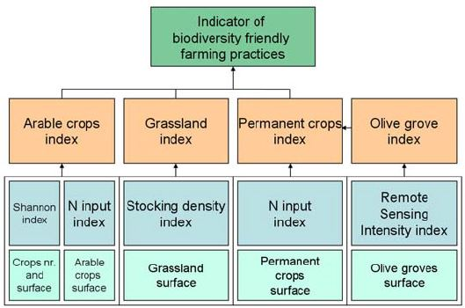

Figure: Scheme of the indicator of biodiversity friendly farming practices reproduced from (Paracchini and Britz, 2010)

The European Grassland Butterfly Indicator

Figure: European grassland butterfly indicator 1990-2013. Source: https://www.eea.europa.eu/data-and-maps/daviz/european-grassland-butterfly-indicator-1

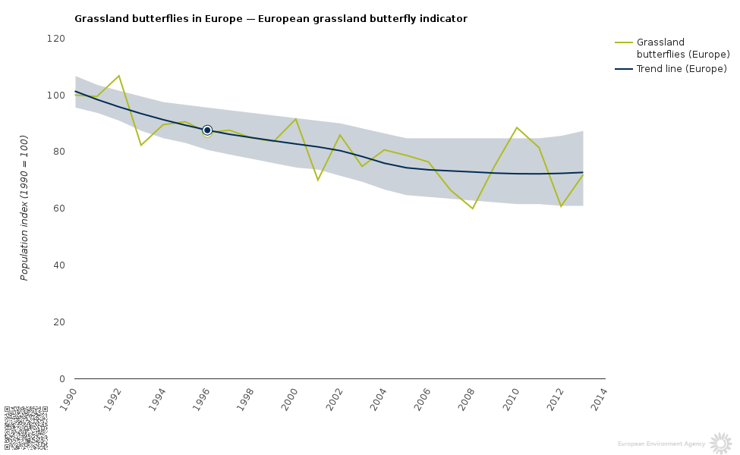

The European Grassland Butterfly Indicator is based on monitoring data from 15 EU countries and 19 EU territories. The EU data may be combined with data from 5 non-EU countries or regions (Andorra, Armenia, Norway, Russia - Bryansk region, Switzerland and Ukraine - Transcarpathia) to generate the Pan-European Grassland Butterfly Indicator. The sampling method is based on the British Butterfly Monitoring Scheme. The indicator draws on the population trends of seven widespread and ten specialist grassland species, as selected by experts (Van Swaay, Warren and Lois, 2006). It is calculated using the TRIM software and approach; more details are provided in (EEA, 2013); see also the UKBMS website. As butterfly numbers fluctuate from year to year, a trend-based assessment is particularly useful. Averaging the species indices, rather than abundances, allows each species to receive equal weighting.

The prototype European hibernating bat indicator.

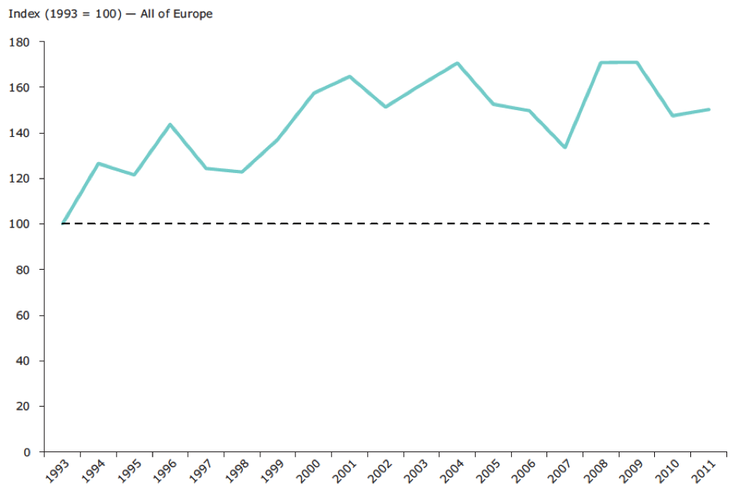
Source: BatLife Europe/Statistics Netherlands.

Nine EU countries have bat hibernation site surveillance schemes that monitor 16 species in the period from 1993 to 2011, forming a dataset suitable for calculating a European-level indicator. In 2006, the Indicator Bats Programme (iBats) was set up with the aim of establishing coordinated regional bat monitoring programmes. As part of the Streamlining European Biodiversity Indicators (SEBI) process, the Bat Conservation Trust reviewed the potential of bats as indicators, assessed the availability of bat monitoring data, and described an appropriate methodology to develop such an indicator (Haysom et al, 2013; Van der Meij et al, 2015). Batlife Europe is advocating for the use of bats as indicators and for efforts to produce an updated indicator. Bat species indices are calculated using TRIM, with the same procedure used for the farmland bird and grassland butterfly indicators. In the UK, bat population trends have been included in national biodiversity indicator statistics since 2008, representing countryside mammals, and in the UK Environmental Change Network. Bat monitoring is well established through the UK National Bat Monitoring Programme, which produces a bat indicator for 11 of 17 resident species.

Uses of biodiversity data to better target agricultural support measures – case studies

UK – England - agri-environment targeting framework

The national targeting core technical group carried out a vast data gathering exercise in order to develop the targeting framework and select the priority species. Research and data were pooled together to assess and select the key themes, species and habitats that need to be addressed by land management. An expert group developed the list of species targeted under the Wild Pollinator and Farm Wildlife Package. The 13 selected bee species (3 bumblebees and 9 solitary bees) are found on farmland, have well-known ecology and distribution, are either declining according to new Red List analyses or have declined prior to the Red List focal period, and are known to benefit from agri-environment measures (Dicks et al, 2015). Information on distribution and abundance was partly based on unpublished analyses of data collected by the Bees, Wasps and Ants Recording Society. The Bird Conservation Targeting Project collated all the available national, regional and local bird survey data for the breeding distribution of farmland and woodland birds including 14 priority species (Phillips et al, 2010). The data were validated by local experts using BirdTrack, and then the validated data were fed into the National Biodiversity Network and mapped using GIS. The Bird Conservation Targeting Project used the National Biodiversity Network gateway to extract all the required data in a uniform format in one step. This dataset and mapped target areas were used to identify priorities for farmland birds in the new England RDP.

The priority habitats were mapped from the England regional Priority Habitat Inventories, supplemented by local estimates of the extent of arable field margins, traditional orchards, hedgerows, rivers, upland flushes, fens and swamps, upland cliff and scree, wood pasture and parkland, brownfield and ponds, where they are available. Complete spatial datasets of priority species distributions were provided by nature conservation organisations. Data were verified by national species specialists. The British Trust for Ornithology Breeding Bird Atlas (Balmer et al, 2013) was used to define where efforts should be targeted for breeding waders.

Monitoring the impact of agri-environment schemes on biodiversity

Monitoring biodiversity impacts of agri-environment and organic farming in Estonia

The Estonian agri-environment and organic monitoring scheme is based on 66 monitored farms or enterprises in two regions of Estonia including 22 farms under the environmentally friendly management scheme (EFM) and 22 organic farms, and a control group of 22 farms that only receive direct payments. The monitoring is only done on the arable part of farms including arable field edges. The monitoring consists of:
- Bumblebee monitoring (2006 onwards) – abundance and species richness along a 500m long and 2m wide transect (of which 400 m is fixed transect located on field edge, with remaining 100 m of transect changing from year-to-year depending on the location of entomophilous crops). Monitoring is carried out three times a year on all sites by researchers from the Estonian University of Life Sciences. Species are identified in the field, and the survey structure takes into account the possibility of identification errors. Data are recorded in blocks of habitat or from one turning point to the other. Biotopes are recorded and flower density is estimated in every block.
- Breeding birds survey (2005 onwards) – breeding bird species are recorded on a 1 km long and 100 m wide transect three times between April and June on an arable field. Carried out by professionals from the Estonian Ornithological Society.
- Vascular plant community surveys (2005-2008 & 2011 onwards) – whole field surveys were carried out in whole fields (2005, 2006, 2008) but discontinued after 2008 because of financial constraints. It has been replaced since 2011 by a vascular plant diversity monitoring scheme on field edges of farms with environmentally friendly management support, carried out in 2011, 2013 and 2016 by researchers from the University of Tartu. The sampling consists of 87 field edges under the EFM basic scheme (which requires in certain cases the establishment of 2-5m grass strips with perennial vegetation or other landscape element). The sampling takes into account that until 2015, the EFM basic could be combined with an additional scheme or with organic farming support, whereas since 2015 the EFM scheme is similar to the previous basic + additional and cannot be combined with organic support.
Earthworm diversity and abundance and soil microbial biomass was also surveyed in 2004-2008 but this was also discontinued due to financial constraints. Additional monitoring and analyses have been carried out to supplement the bumblebee monitoring, including an analysis of landscape structure and diversity, plant species visited by bumblebees, pesticide and fertiliser applications on fields monitored for farmland birds, etc.

Methodology of the Welsh Glastir Monitoring and Evaluation Programme (GMEP)

The Glastir (agri-environment) Monitoring and Evaluation Programme collects data from an annual field survey across Wales, including species diversity of plants, pollinators and birds, habitat condition indicators, and occurrence or extent and condition of UK priority species and habitats, which are a priority target for Glastir measures (Emmett et al, 2017). The field survey data are complemented by species data from volunteer schemes in Wales. The GMEP field survey assesses 300 1km² plots, half which form the ‘wider Wales’ survey of 150 squares randomly selected from 26 land classes to ensure good representation of widespread broad habitats and the wider countryside. A ‘Targeted Survey’ of 150 squares targeted for Glastir payments were chosen to capture Glastir effects. The sites are visited on a 4-year rolling cycle.

The bird survey protocol provides a robust estimate of total numbers of breeding pairs of birds of each species found in each survey square and thus of change over time in future surveys, as well as information on the habitat patches in which individuals were recorded. The protocol operates at the same spatial scale as the national BTO/JNCC/RSPB Breeding Bird Survey (BBS), but involves more intensive fieldwork, so it provides more accurate measures of local abundance and is more appropriate for surveying smaller samples of squares with lower rates of repetition.

Pollinator surveys focused on three main pollinator groups: butterflies (Lepidoptera: Rhopalocera), bees (Hymenoptera: Apoidea) and hoverflies (Diptera: Syrphidae). Butterflies were recorded to species level, whilst bees and hoverflies were recorded as groups based on broad differences in morphological features associated with ecological differences. In addition, the abundance of common flowering plant groups (identified at the time of survey) was also recorded using the DAFOR-X scale. Surveys were split into two independent parts: a standardised 2km transect route through each 1km² followed by a timed search in a 150m² flower-rich area within the square. Surveys also monitor the populations of UK priority species which are associated with specific Glastir options, to determine whether survey squares associated with option uptake affect these. These data are at a 1km resolution.

The scheme reported on a newly developed Priority Bird Index of 35 species with sufficient trend data available in Wales. For all other priority species, GMEP is developing metrics quantifying improvement in habitat specifically required for each species. Six species or groups were selected to start this process; Lapwing (Vanellus vanellus), Curlew (Numenius arquata), Hazel Dormouse (Muscardinus avellanarius), rare arable plants, Lesser Horseshoe Bat (Rhinolophus hipposideros) and the Marsh Fritillary butterfly (Euphydryas aurinia). Additional components of GMEP are the analysis of long term data from other schemes in combination with GMEP data where possible; modelling future outcomes to maximise the impact of payments; surveys to assess wider socio-economic benefits; and development of novel technologies to increase detection and efficiency of future assessments.

Proposal for wild pollinator monitoring scheme in the UK

The proposal for a systematic UK wild pollinator monitoring scheme (Carvell et al, 2016) developed a standardised protocol for monitoring pollinators in the wider environment at the broad group level (bumblebees, solitary bees, hoverflies) and at species-level for a few common species. The proposal identifies a list of 37 candidate species that are common widespread effective pollinators of crops in the UK (6 bumblebees, 13 solitary bees, honeybee, and 17 hoverflies). The proposed monitoring uses a combination of three different sampling methods which can be carried out by trained volunteers with professional staff support, including pan traps, fixed transect walks and timed focal flower observations. Five potential options for a monitoring programme with different levels of professional and volunteer involvement were estimated to cost between €60 thousand (£49 thousand) to €10 million (£8.6 million) over 10 years. The authors estimate that between 20 and 75 sites across Great Britain could provide statistical sufficient power (>80%) to detect a 30-50% change over 10 years for widespread, common species or groups (e.g. change in the summed abundance of bumblebees) with annual counts of 10 or more individuals per site. Detecting 10-year changes of 30% in direct measures of pollination service or deficit would require between 100-200 fields per crop.

The IFAB arable biodiversity and landscape features survey

The IFAB survey investigated the state of biodiversity and landscape features on arable land in 39 regions in 10 European countries in summer 2014 using a systematic standardized methodology, aiming to include intensive as well as extensive areas, achieve coverage of different geographical and natural regions, and identify homogenous regions (IFAB, 2015). In total 22 surveyors investigated about 800 plots each of 25 ha in size. Each survey took about 5-6 days and involved: estimation of nature value based on a field guide; transect (30m) count of potential key species on arable and grassland (from European lists of around 100 species for arable and for grassland respectively); transect count of number of flowering plant species, flower density and coverage of wild plants; records of observed land use elements and ecologically valuable sites including buffer strips; photographic evidence of land use and nature situations and good and bad land use practices.

The plant diversity and abundance surveys found 0-1 key species in most of the arable regions, even where plant diversity was expected to be higher. The low number of key plant species was not correlated with wild plant coverage. The cereals, maize, and sunflowers had mean coverage near to 0% with very few more than 5%. The root crops were almost free of any segetal vegetation at less than 1% coverage. The only crop with higher coverage was alfalfa with a medium coverage of wild plants of about 5% and with 50% of all values between 2-35% coverage. Two regions were exceptions: the Spanish region Castilla North had a mean value of 5% coverage of wild plants in both arable land in general and in cereals. In the polish region Chojna there was about 2% coverage of wild plants in arable land and in cereals.

The survey was repeated in summer 2016. The survey team proposes the methodology as a suitable model for ongoing EU-wide monitoring of arable farmland (IFAB, 2015).

References

Balmer, D E, Gillings, S, Caffrey, B J, Swann, R L, Downie, I S and Fuller, R J (2013) Bird Atlas 2007-11: the breeding and wintering birds of Britain and Ireland. BTO Books, Thetford, UKpp.

Benzler, A, Fuchs, D and Hünig, C (2015) Monitoring and first results of High Nature Value Farmland Monitoring in Germany: evidence of ongoing biodiversity loss within agricultural landscapes. Natur & Landschaft No 90 (7), 309-316.

Carvell, C, Isaac, N J B, Jitlal, M, Peyton, J, Powney, G D, Roy, D B, Vanbergen, A J, O'Connor, R S, Jones, C M, Kunin, W E, Breeze, T D, Garratt, M P D, Potts, S G, Harvey, M, Ansine, J, Comont, R F, Lee, P, Edwards, M, Roberts, S P M, Morris, R K A, Musgrove, A J, Brereton, T, Hawes, C and Roy, H E (2016) Design and Testing of a National Pollinator and Pollination Monitoring Framework. A report to the Department for Environment, Food and Rural Affairs (Defra), Scottish Government and Welsh Government: Project WC1101, Centre for Ecology & Hydrology.

Crowe, O, Coombes, R H and O’Halloran, J (2014) Estimates and trends of common breeding birds in the Republic of Ireland. Irish Birds No 10, 23-32.

datagvat (2015) Trockenrasenkatalog 1986. https://www.data.gv.at/katalog/dataset/0b2a0735-b368-4fb6-bf00-27b28b0ac2b4 Accessed

Dicks, L V, Baude, M, Roberts, S, Phillips, J, Green, M and Carvell, C (2015) How much flower-rich habitat is enough for wild pollinators? Answering a key policy question with incomplete knowledge. Ecological Entomology No 40 (S1), 22-35.

EEA (2013) The European Grassland Butterfly Indicator: 1990-2011. Technical report No 11/2013, European Environment Agency, Copenhagen.

Emmett, B E, Abdalla, M, Anthony, S, Astbury, S, August, T, Barrett, G, Beckman, B, Biggs, J, Botham, M, Bradley, D, Brown, M, Carter, H, Chadwick, D, Cigna, F, Collier, R, Cooper, D, Cooper, J, Cosby, B J, Creer, S, Cross, P, Dadam, D, Edwards, F, Edwards, M, Evans, C, Ewald, N, Fitton, A, Garbutt, A, Giampieri, C, Gooday, R, Grebby, S, Greene, S, Halfpenney, I, Hall, J, Harrison, S, Harrower, C, Henrys, P, Hobson, R, Hughes, P, Hughes, S, Illian, J, Isaac, N, Jackson, B, Jarvis, S, Jones, D L, Jones, P, Keith, A, Kelly, M, Kneebone, N, Korenko, J, Lallias, D, Leaver, D, Lebron, I, Malcolm, H, Maskell, L, McDonald, J, Moxley, J, Norton, L, O’Hare, M, Oliver, T, Owen, A, Parkhill, K A, Pereira, M, Peyton, J, Pogson, M, Powney, G, Pritchard, N, Pritchard, S, Prochorskaite, A, Prosser, M, Pywell, R, Rawlins, B, Reuland, O, Richards, M, Robinson, D A, Rorke, S, Rowland, C, Roy, D, Scarlett, P, Scholefield, P, Scott, A, Scott, L, Scott, R, Sharps, K, Siriwardena, G, Smart, S, Smith, G, Smith, P, Stopps, J, Swetnam, R, Taft, H, Taylor, R, Tebbs, E, Thomas, A, Todd-Jones, C, Tordoff, G, Turner, G, Van Breda, J, Vincent, H, Wagner, M, Waters, E, Walker-Springett, K, Wallace, H, Watkins, J, Webb, G, White, J, Whitworth, E, Williams, B, Williams, P, Wood, C and Wright, S (2017) Glastir Monitoring & Evaluation Programme. Final Report to Welsh Government. Contract reference: C147/2010/11. NERC/Centre for Ecology & Hydrology (CEH Projects: NEC04780/NEC05371/NEC05782), Gwynedd, Walespp.

Haysom, K, Dekker, J, Russ, J, van der Meij, T and Van Strien, A (2013) European bat population trends: A prototype biodiversity indicator. EEA Techncial Report No. 19/2013, European Environment Agency, Copenhagen.

IFAB (2015) Landscape infrastructure and sustainable agriculture (LISA): Report on the investigation in 2014. Institute for Agroecology and Biodiversity (IFAB) supported by INEA, jKi, Gregor Louisoder Umweltstiftung, EEB, Germany.

JNCC (2007) UK BAP Broad Habitats, in Dataset. Joint Nature Conservation Committee, UK.

Jordbruksverket (2013) Databasen TUVA, in Dataset. Sweden.

PAN, IFAB and ILN (2011) Umsetzung des High Nature Value Farmland-Indikators in Deutschland [Report HNV farmland monitoring results Germany]. F+E-Vorhaben "Umsetzung des HNV-Indikators" Projektbericht Ergebnisse eines Forschungsvorhabens (UFOPLAN FKZ 3508 89 0400) im Auftrag des Bundesamtes für Naturschutz, PAN Planungsbüro für angewandten Naturschutz GmbH, Institut für Agrarökologie und Biodiversität (IFAB) & Institut für Landschaftsökologie und Naturschutz.

Paracchini, M L and Britz, W (2010) Quantifying effects of changed farm practices on biodiversity in policy impact assessment – an application of CAPRI-Spat. OECD, Paris.

Phillips, J, Winspear, R, Fisher, S and Noble, D (2010) Targeting agri-environment schemes for farmland birds in England, BOU Proceedings - Lowland Farmland Birds III. British Ornithology Union, UK.

UBA (2013) MAES Habitat-Karte 10m, in Dataset. Umweltbundesamt GmbH, Austria.

UBA (2015) Bioptoptypen-Verbreitung: Grünland, in Dataset. Umweltbundesamt GmbH, Austria.

Van der Meij, T, van Strien, A J, Haysom, K A, Dekker, J, Russ, J, Biala, K, Bihari, Z, Jansen, E, Langton, S, Kurali, A, Limpens, H, Meschede, A, Petersons, G, Presetnik, P, Prüger, J, Reiter, G, Rodrigues, L, Schorcht, W, Uhrin, M and Vintulis, V (2015) Return of the bats? A prototype indicator of trends in European bat populations in underground hibernacula. Mammalian Biology - Zeitschrift für Säugetierkunde No 80 (3), 170-177.

Van Swaay, C, Warren, M and Lois, G (2006) Biotope use and trends of European butterflies. Journal of Insect Conservation No 10 (2), 189-209.

http://www.birdwatchireland.ie/OurWork/ResearchSurveys/CountrysideBirdSurvey/CBSAnalyses/tabid/535/Default.aspx
http://www.ebcc.info/index.php?ID=608
http://www.ukbms.org/popup_texts/calculation.htm
The group was made up of Natural England colleagues representing all the key objectives along with representatives from Defra, the Environment Agency and the Forestry Commission England.
Somerset Local Nature Partnership (2014a) NELMs national targeting framework. Available at: http://slnp.org.uk/wp-content/uploads/2014/11/NELMS-Targeting-Framework-October-2014-final.doc
The Bird Conservation Targeting Project is a joint Natural England, RSPB, BTO and Forest Commission initiative which works closely together with BirdTrack (www.birdtrack.net), a partnership between the BTO, the RSPB and BirdWatch Ireland, with the aim of automating the process of collating bird records. Local bird clubs and individuals are encouraged to share their bird data in BirdTrack and/or the National Biodiversity Network, and efforts are ongoing to integrate BirdTrack with the NBN web services.
Regional inventories are available for central-eastern, central-western, north-eastern, north-western, south-eastern and south-western England. Available at: Natural England (2016) GIS Digital Boundary Datasets. http://www.gis.naturalengland.org.uk/pubs/gis/gis_register.asp
For woodland, broad habitat data from a previous analysis were included on the advice of government woodland experts in preference to the priority habitat inventories which were deemed unreliable. Personal communication, Clive Porro, Natural England December 2015.
RSPB, BTO, Plantlife, BSBI, Butterfly Conservation, ARC, Natural England, Buglife and the Bat Conservation Trust
Notably Natural Resources Wales, the National Forestry Inventory, Plantlife, UK Butterfly Monitoring Scheme, the Breeding Bird Scheme and Countryside Survey.

